Docker Task -2

Step1:

Creating the docker compose.yml file use respective script

Screenshot mentioned below:

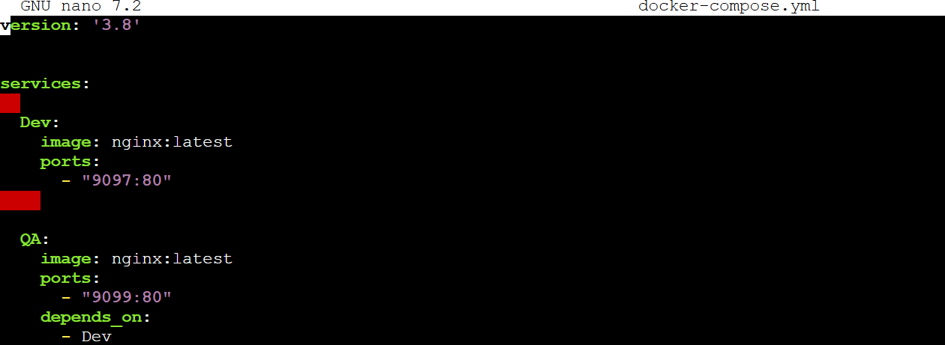

Step 2:

After that using this yml file run the command is docker-compose up the web application is Up and now if we try to hit the server we can able to see

Screenshot mentioned below:

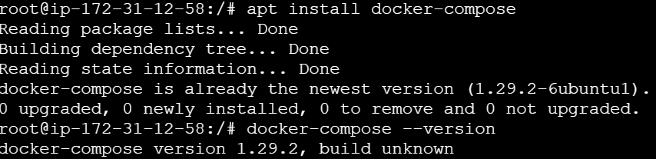

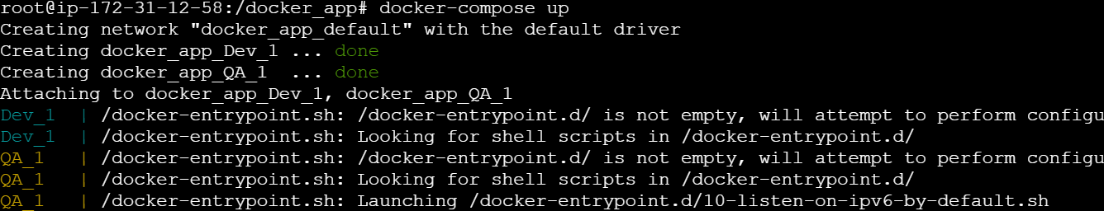



Step 3:

If we try to hit with public Ip <http://13.203.97.73:9097/>

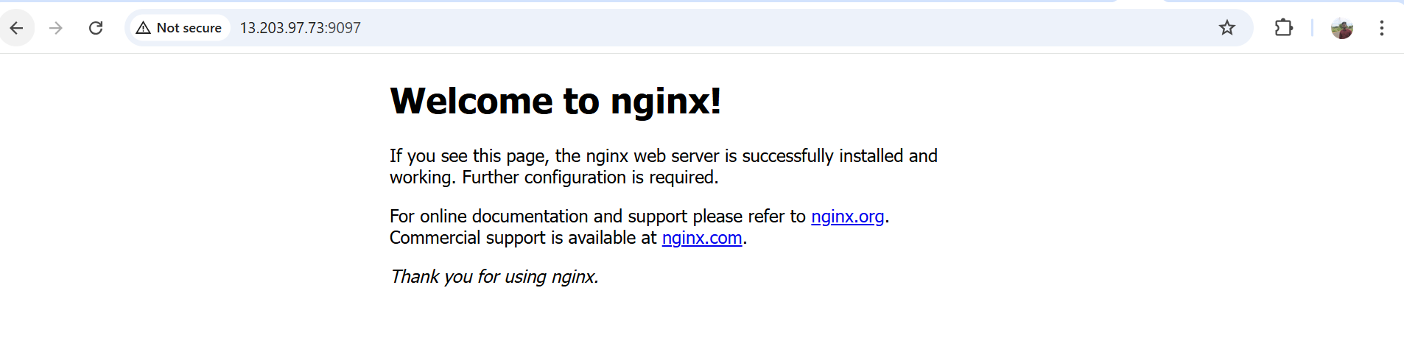

Step 5:

Dockerfile app.py using the basic Details creating the image

Screenshot mentioned Below:

App.py file

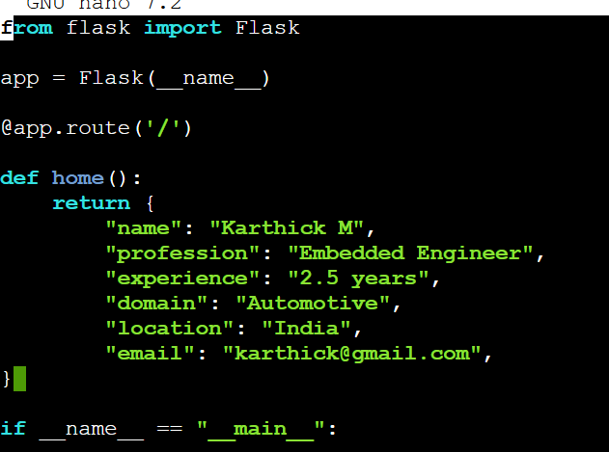

Docker commands executing :

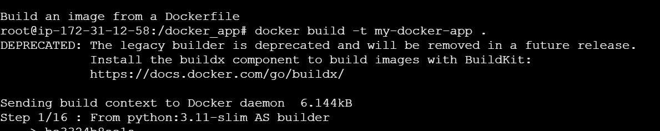

C:\My folder\Devops_MainBoot_Info\Task\Task12_19.06.2025\Screenshot 2025-06-18 210017.png



Step 6:

Try to hit this ip <http://13.204.46.82:9110/>

